**ASSIGNMENT 1  
JAVA**

**Lavanya Saini – 22BCS15497**

1. **String Analysis**

import java.util.Scanner;

public class StringAnalysis {

public static void main(String[] args) {

Scanner sc = new Scanner(System.in);

try {

System.out.print("Enter a string: ");

String str = sc.nextLine();

int vowels = 0, consonants = 0, digits = 0, specialChars = 0;

str = str.toLowerCase();

for (int i = 0; i < str.length(); i++) {

char ch = str.charAt(i);

if (ch >= 'a' && ch <= 'z') {

if ("aeiou".indexOf(ch) != -1)

vowels++;

else

consonants++;

} else if (ch >= '0' && ch <= '9') {

digits++;

} else if (ch != ' ') {

specialChars++;

}

}

System.out.println("Vowels: " + vowels);

System.out.println("Consonants: " + consonants);

System.out.println("Digits: " + digits);

System.out.println("Special Characters: " + specialChars);

} finally {

sc.close();

}

}

}

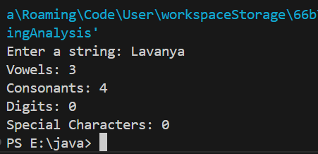

1. **Matrix Operations**

import java.util.Scanner;

public class MatrixOperations {

public static void main(String[] args) {

Scanner sc = new Scanner(System.in);

try {

System.out.print("Enter rows and columns of Matrix A: ");

int rowsA = sc.nextInt();

int colsA = sc.nextInt();

int[][] A = new int[rowsA][colsA];

System.out.println("Enter elements of Matrix A:");

for (int i = 0; i < rowsA; i++)

for (int j = 0; j < colsA; j++)

A[i][j] = sc.nextInt();

System.out.print("Enter rows and columns of Matrix B: ");

int rowsB = sc.nextInt();

int colsB = sc.nextInt();

int[][] B = new int[rowsB][colsB];

System.out.println("Enter elements of Matrix B:");

for (int i = 0; i < rowsB; i++)

for (int j = 0; j < colsB; j++)

B[i][j] = sc.nextInt();

System.out.println("\nMatrix Addition:");

if (rowsA == rowsB && colsA == colsB)

addMatrices(A, B, rowsA, colsA);

else

System.out.println("Addition not possible (Dimensions don't match)");

System.out.println("\nMatrix Subtraction:");

if (rowsA == rowsB && colsA == colsB)

subtractMatrices(A, B, rowsA, colsA);

else

System.out.println("Subtraction not possible (Dimensions don't match)");

System.out.println("\nMatrix Multiplication:");

if (colsA == rowsB)

multiplyMatrices(A, B, rowsA, colsA, colsB);

else

System.out.println("Multiplication not possible (Invalid dimensions)");

} finally {

sc.close();

}

}

static void addMatrices(int[][] A, int[][] B, int r, int c) {

for (int i = 0; i < r; i++) {

for (int j = 0; j < c; j++) {

System.out.print((A[i][j] + B[i][j]) + " ");

}

System.out.println();

}

}

static void subtractMatrices(int[][] A, int[][] B, int r, int c) {

for (int i = 0; i < r; i++) {

for (int j = 0; j < c; j++) {

System.out.print((A[i][j] - B[i][j]) + " ");

}

System.out.println();

}

}

static void multiplyMatrices(int[][] A, int[][] B, int r1, int c1, int c2) {

int[][] result = new int[r1][c2];

for (int i = 0; i < r1; i++) {

for (int j = 0; j < c2; j++) {

for (int k = 0; k < c1; k++) {

result[i][j] += A[i][k] * B[k][j];

}

System.out.print(result[i][j] + " ");

}

System.out.println();

}

}

}

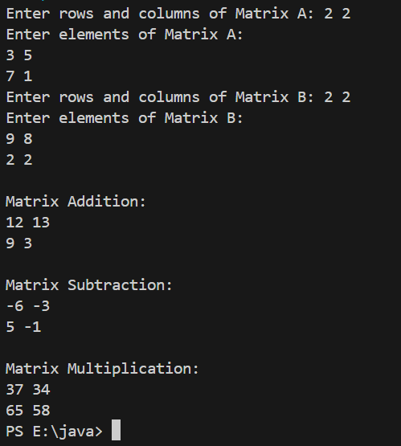

1. **Basic Banking System**

import java.util.Scanner;

class BankAccount {

private String name;

private String accountNumber;

private double balance;

public BankAccount(String name, String accountNumber, double balance) {

this.name = name;

this.accountNumber = accountNumber;

this.balance = balance;

}

public String getName() {

return name;

}

public String getAccountNumber() {

return accountNumber;

}

public double getBalance() {

return balance;

}

public void deposit(double amount) {

if (amount > 0) {

balance += amount;

System.out.println("Amount Deposited: " + amount);

} else {

System.out.println("Invalid deposit amount!");

}

}

public void withdraw(double amount) {

if (amount > balance) {

System.out.println("Insufficient Balance!");

} else if (amount > 0) {

balance -= amount;

System.out.println("Amount Withdrawn: " + amount);

} else {

System.out.println("Invalid withdrawal amount!");

}

}

public void displayAccount() {

System.out.println("Name: " + name);

System.out.println("Account Number: " + accountNumber);

System.out.println("Balance: " + balance);

}

}

public class BankingSystem {

public static void main(String[] args) {

Scanner sc = new Scanner(System.in);

System.out.print("Enter Name: ");

String name = sc.nextLine();

System.out.print("Enter Account Number: ");

String accNumber = sc.nextLine();

System.out.print("Enter Initial Balance: ");

double balance = sc.nextDouble();

BankAccount account = new BankAccount(name, accNumber, balance);

while (true) {

System.out.println("\n1. Deposit");

System.out.println("2. Withdraw");

System.out.println("3. View Account Details");

System.out.println("4. Exit");

System.out.print("Enter choice: ");

int choice = sc.nextInt();

switch (choice) {

case 1:

System.out.print("Enter Amount to Deposit: ");

double depositAmt = sc.nextDouble();

account.deposit(depositAmt);

break;

case 2:

System.out.print("Enter Amount to Withdraw: ");

double withdrawAmt = sc.nextDouble();

account.withdraw(withdrawAmt);

break;

case 3:

account.displayAccount();

break;

case 4:

System.out.println("Thank you for banking with us!");

sc.close();

return;

default:

System.out.println("Invalid choice! Try again.");

}

}

}

}

